Week 9 Assignment
DBMS
Name : Satlas Rohit B
Regno : 2024503305
1. Insert, update, delete on simple views that reflects views and base table.
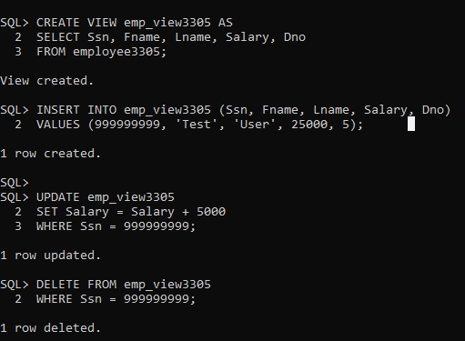

2. Insert, delete, update on simple views that violate the constraint such as primary key. Note: primary key of a table is a foreign key on other table.
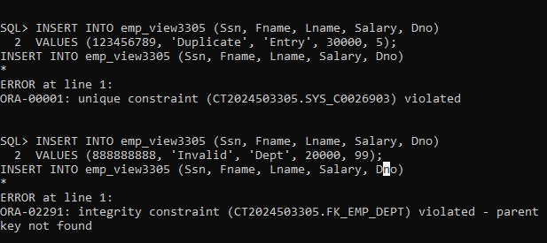

3. Insert, update, delete on complex views that reflects views and base table
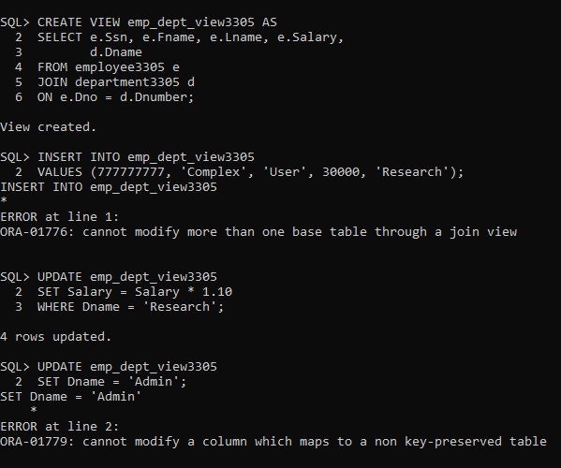

4. Drop view and perform query on base table and vice versa.
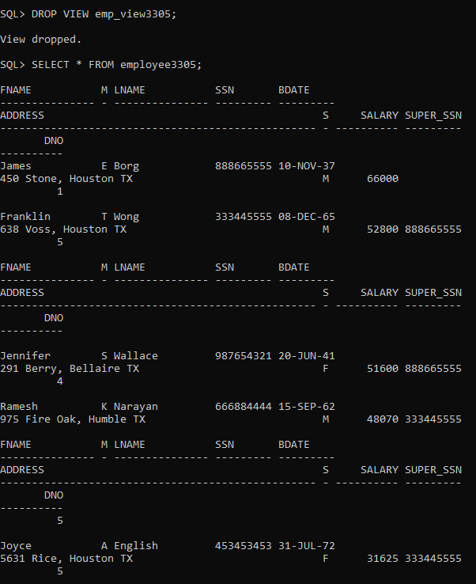
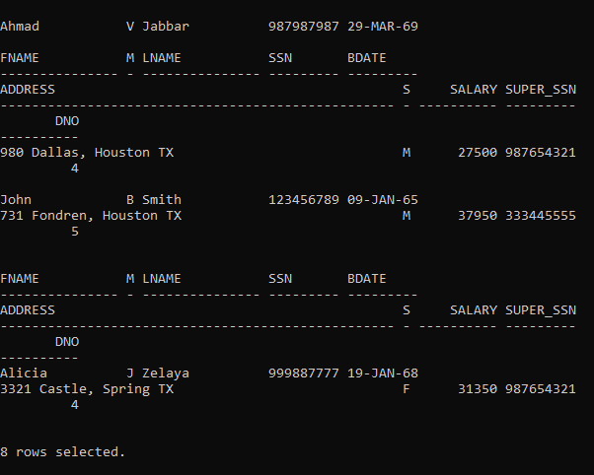

5. Drop column in base table after creation of view with the respective column and perform select query on view.
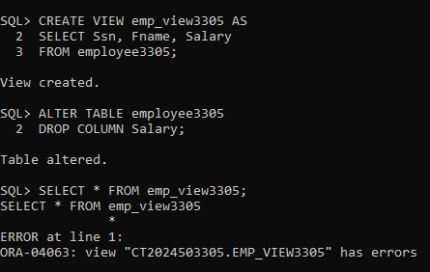

6. Rename column in base table after creation of view with the respective column and perform select query on view.
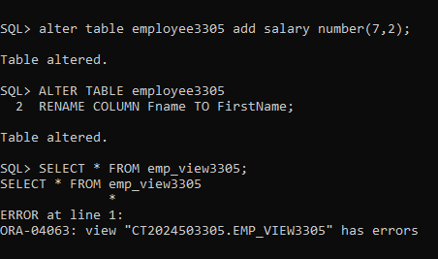

7. Rename table in base table after creation of view and perform select query on view.
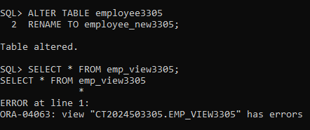

8. Modify data type of a column in base table after creation of view with the respective column and perform select query on view.
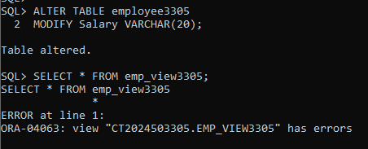

9. Create a view from existing view
